AI-Powered Student Engagement Monitoring System for Online Classrooms

A PROJECT REPORT

Submitted by

GILBERT.J 21052421032
ADWIN JEFRITH.J 21052421003
BANIAS LENIN.L 21052421013
JESON JASHAR.I 21052421042

In partial fulfilment for the award of the degree
of
BACHELOR OF ENGINEERING
IN
COMPUTER SCIENCE AND ENGINEERING


DMI COLLEGE OF ENGINEERING,
CHENNAI - 600 123
(An Autonomous Institution)

APRIL 2026

BONAFIDE CERTIFICATE

This is to certify that the project report titled “AI-Powered Student Engagement Monitoring System for Online Classrooms” is the bonafide work of “GILBERT.J (21052421032),ADWIN JEFRITH.J (21052421003),BANIAS LENIN.L (21052421013) and JESON JASHAR.I (21052421042)”who carried out the project work under my supervision.

SIGNATURE  Dr.V.SURESH KUMAR M.E., Ph.D.,  HEAD OF THE DEPARTMENT,  PROFESSOR,  Department of Computer Science and  Engineering,  DMI College of Engineering,  Chennai – 600 123. | SIGNATURE  Mrs.V.LAVANYA,M.Tech.,  ASSISTANT PROFESSOR,  Department of Computer Science and  Engineering,  DMI College of Engineering,  Chennai – 600 123

End Semester-Project Viva-Voce held on | ________________

Internal Examiner External Examiner

ACKNOWLEDGEMENT

We are immensely pleased in taking up this opportunity to thank the
LORD ALMIGHTY for showering this unlimited blessing upon us.

We take this opportunity to express our gratitude to our Founder and
Chairman Rev.Fr.Dr.J.E.Arulraj and our Administrator
Rev.Sr.J.Arockia Johnci Rani for allowing us to take over this project.

We thank our principal Dr.Sujatha Jamuna Anand, M.Tech., Ph.D., who has always served as an inspiration for me to carry out our responsibilities also providing comfort zone for doing this project work

I extend my heartfelt gratitude to Dr.V.Suresh Kumar, M.E., Ph.D., Head of the Department of, for the continuous guidance and motivation provided during this endeavor.

I am extremely grateful to my project guide Mrs. V.Lavanya, M.Tech Assistant Professor , Department of Computer Science & Engineering , for the invaluable guidance,constant encouragement, and insightful suggestions rendered throughout the course of thisproject work.

It is a pleasure to acknowledge our indebtedness to all the Teaching and Non Teaching staff of Department of Computer Science and Engineering who aided us successfully to bring our project as an effective one. Further thanks to our parents, our family members and friends for their moral support.

ABSTRACT

The shift to online education, accelerated by the global pandemic, has introduced significant challenges in monitoring student engagement and attendance in virtual classrooms. Traditional methods of manual attendance and visual observation are impractical in an online setting. This project presents an AI-Powered Student Engagement Monitoring System that leverages real-time face detection and head pose estimation to automatically track student attention during online classes.
The system employs a client-server architecture with a React-based frontend and a FastAPI backend, connected through RESTful APIs and Socket.IO for real-time communication. On the client side, face-api.js (a JavaScript implementation of face detection using TinyFaceDetector and 68-point landmark detection) processes the student’s webcam feed entirely within the browser to ensure privacy-first design — no video or images are transmitted to the server. Only boolean metadata (face detected, attention score, number of faces) is sent to the backend.
On the server side, Google MediaPipe Face Mesh with 468 facial landmarks provides optional secondary detection capability. The backend uses MongoDB for persistent storage, JWT-based authentication with bcrypt password hashing, and WebSocket/Socket.IO for broadcasting real-time engagement updates to teachers.
The system calculates an engagement percentage based on the ratio of time a student is “attentive” (face detected, centered, looking at screen) to total class duration. Students with ≥70% engagement are automatically marked Present; those below the threshold are marked Absent. Teachers receive a live engagement dashboard with per-student visual indicators and can generate finalized attendance reports with CSV/Excel export at the end of each class session.

TABLE OF CONTENTS

CHAPTER NO. | TITLE | PAGE NO.
 | Bonafide Certificate
 | Acknowledgement
 | Abstract
 | Table of Contents | i
 | List of Figures | iii
 | List of Tables | iii
 | List of Abbreviations | iv
1 | INTRODUCTION | 1
1.1 | Overview | 1
1.2 | Problem Statement | 1
1.3 | Objectives | 2
1.4 | Scope of the Project | 2
1.5 | Organization of the Report | 3
2 | LITERATURE SURVEY | 4
2.1 | Existing Systems | 4
2.2 | Face Detection Techniques | 4
2.3 | Head Pose Estimation | 5
2.4 | Gaps in Existing Literature | 5
3 | SYSTEM ANALYSIS AND DESIGN | 6
3.1 | System Requirements | 6
3.2 | Use Case Diagram | 7
4 | SYSTEM ARCHITECTURE | 8
4.1 | Architectural Overview | 8
4.2 | Frontend Architecture | 9
4.3 | Backend Architecture | 9
4.4 | Real-Time Communication Layer | 11
5 | IMPLEMENTATION | 12
5.1 | Development Environment | 12
5.2 | Backend Implementation | 12
5.3 | Frontend Implementation | 16
5.4 | Face Detection Implementation | 17
5.5 | Attendance Algorithm | 19
6 | TESTING AND RESULTS | 20
6.1 | Testing Methodology | 20
6.2 | Unit Testing | 20
6.3 | Integration Testing | 20
6.4 | System Testing Results | 20
6.5 | Performance Analysis | 22
7 | CONCLUSION AND FUTURE ENHANCEMENTS | 23
7.1 | Conclusion | 23
7.2 | Future Enhancements | 24
 | APPENDIX A – SOURCE CODE | 24
 | APPENDIX B – SCREENSHOTS | 25
 | REFERENCES | 29

LIST OF FIGURES

Figure No. | Title | Page
3.1 | Use Case Diagram | 7
4.1 | Architecture Overview | 8
6.1 | Login Page | 25
6.2 | Registration Page | 25
6.3 | Teacher Dashboard | 26
6.4 | Student Dashboard | 26
6.5 | Virtual Classroom — Teacher View | 27
6.6 | Live Engagement Panel | 28

LIST OF TABLES

Table No. | Title | Page
3.1 | Hardware Requirements | 6
3.2 | Software Requirements | 6
5.1 | Backend Python Dependencies | 14
5.2 | API Endpoints Summary | 15
5.3 | Frontend Node.js Dependencies | 17
6.1 | Test Cases and Results | 20
6.2 | Performance Metrics | 22

LIST OF ABBREVIATIONS

 | ABBREVIATION | ACRONYM
AI |  | Artificial Intelligence
ML |  | Machine Learning
API |  | Application Programming Interface
ASGI |  | Asynchronous Server Gateway Interface
CORS |  | Cross-Origin Resource Sharing
CSS |  | Cascading Style Sheets
CSV |  | Comma Separated Values
DOM |  | Document Object Model
HTTP |  | Hypertext Transfer Protocol
ICE |  | Interactive Connectivity Establishment
JWT |  | JSON Web Token
REST |  | Representational State Transfer
SHA |  | Secure Hash Algorithm
SPA |  | Single Page Application
STUN |  | Session Traversal Utilities for NAT
UI |  | User Interface
UX |  | User Experience
WebRTC |  | Web Real-Time Communication
WS/WSS |  | WebSocket / WebSocket Secure

CHAPTER 1

INTRODUCTION

1.1 Overview
The rapid proliferation of online education platforms has created an unprecedented need for tools that replicate the oversight capabilities of traditional physical classrooms. In a face-to-face setting, instructors can naturally observe facial cues, body language, and attentiveness. In an online environment, these cues are largely absent, making it difficult for educators to gauge whether students are truly engaged or merely logged in passively.
This project, titled “AI-Powered Student Engagement Monitoring System for Online Classrooms,” addresses this gap by developing a comprehensive web-based virtual classroom platform that incorporates artificial intelligence techniques — specifically face detection, facial landmark analysis, and head pose estimation — to automatically monitor and quantify student engagement in real time.
The system provides role-based dashboards for teachers and students. Teachers can create classes, start live sessions, view real-time engagement bars for every connected student, and generate post-session attendance reports. Students join classes, enable their webcam, and have their engagement tracked automatically — with all face detection performed locally in the browser to ensure privacy.

1.2 Problem Statement
Existing online education platforms (Zoom, Google Meet, Microsoft Teams) provide basic video conferencing capabilities but lack automated, AI-driven engagement monitoring. The key challenges are:
- Manual attendance is unreliable: Students can log in and leave, or attend without paying attention.
- Privacy concerns: Transmitting video streams to external servers for AI processing raises significant privacy and data protection issues.
- Lack of quantitative engagement metrics: Teachers have no numerical or visual metric to assess per-student attention levels.
- No automated present/absent determination: At the end of a session, teachers must manually check who was attentive and for how long.
- Real-time feedback gap: Teachers cannot see, in real time, which students are looking away, have turned off their cameras, or have left the frame.

1.3 Objectives
The primary objectives of this project are:
- To design and implement a web-based virtual classroom platform with AI-powered face detection for automatic student engagement monitoring.
- To implement a privacy-first architecture where face detection runs entirely in the student’s browser, transmitting only metadata (no images or video) to the server.
- To provide teachers with a real-time engagement dashboard displaying per-student attention status (attentive, distracted, or not detected).
- To automate attendance marking based on configurable engagement thresholds (default: ≥70% engagement = Present).
- To support WebRTC-based video/audio communication for live classroom sessions with screen sharing, chat, and hand-raise capabilities.
- To generate finalized attendance reports with CSV and Excel export functionality.
- To implement secure JWT-based authentication with role-based access control (teacher vs. student).

1.4 Scope of the Project
The scope of this project includes:
- User Authentication: Registration and login for teachers and students with JWT tokens and bcrypt password hashing.
- Classroom Management: Teachers can create, schedule, activate, and end class sessions. Students can join classes using a unique Class ID.
- Real-Time Face Detection: Client-side face detection using face-api.js (TinyFaceDetector + 68-point facial landmarks) running in the student’s browser.
- Server-Side Face Detection (Optional): MediaPipe Face Mesh with 468 landmarks for legacy/fallback frame analysis.
- Engagement Calculation: Continuous tracking of face presence, head pose, and attention score to compute engagement percentage.
- Real-Time Updates: Socket.IO-based bidirectional communication for live engagement updates to the teacher’s dashboard.
- Attendance Reports: Automatic generation of attendance records with present/absent status, engagement time, and export capabilities.
- WebRTC Video/Audio: Peer-to-peer video and audio communication using a star topology (teacher ↔ each student).
- Responsive UI: React-based single-page application with Tailwind CSS for responsive, modern design.

1.5 Organization of the Report
This report is organized into seven chapters:
- Chapter 1 introduces the project, states the problem, and defines the objectives and scope.
- Chapter 2 presents a literature survey of related work in face detection, engagement monitoring, and real-time web communication.
- Chapter 3 covers system analysis and design, including requirements, use case diagrams, data flow diagrams, and database schema.
- Chapter 4 describes the system architecture in detail, including frontend, backend, database, and communication layers.
- Chapter 5 provides a detailed account of the implementation, covering backend modules, frontend components, face detection algorithms, and the attendance calculation logic.
- Chapter 6 discusses the testing methodology, test cases, results, and performance analysis.
- Chapter 7 presents the conclusion, contributions of the project, and potential future enhancements.

CHAPTER 2

LITERATURE SURVEY

2.1 Existing Systems
Zoom and Google Meet provide video conferencing with basic participant monitoring (raised hands, chat). However, they do not offer automated engagement or attention tracking through AI. Some third-party plugins (e.g., ClassDojo, Proctorio) provide partial monitoring, but they typically require full video stream access, raising privacy concerns.
Proctoring platforms such as Proctorio, ExamSoft, and Respondus LockDown Browser are designed for exam invigilation rather than general classroom engagement. They operate by capturing screen/webcam video and transmitting it to remote servers, which conflicts with data privacy regulations such as GDPR and India’s Personal Data Protection Bill.
ClassDojo tracks behavioral engagement through manual teacher input rather than automated face detection. It is suitable for K-12 but lacks the AI capabilities needed for continuous university-level engagement monitoring.

2.2 Face Detection Techniques
Face detection has evolved significantly over the past decade:
- Viola-Jones Algorithm (2001): The pioneering cascade classifier using Haar-like features. Fast but limited in accuracy with non-frontal faces and variable lighting [1].
- HOG + SVM (Dalal & Triggs, 2005): Histogram of Oriented Gradients with a linear SVM classifier. More robust than Viola-Jones but computationally expensive for real-time web applications [2].
- MTCNN (Zhang et al., 2016): Multi-Task Cascaded Convolutional Neural Networks. Achieves high accuracy with three cascaded CNNs but requires significant GPU resources [3].
- TinyFaceDetector (Justadudewhohacks, 2018): A lightweight MobileNet-based SSD detector optimized for browser execution via TensorFlow.js. Used in the face-api.js library, it provides real-time face detection with low computational overhead, making it ideal for client-side processing [4].
- Google MediaPipe Face Mesh (2020): Detects 468 facial landmarks in 3D using a pipeline of BlazeFace (for face detection) and a mesh regression network. Achieves sub-millisecond performance on mobile devices and can estimate head pose through 3D landmark positions [5].
This project uses TinyFaceDetector (via face-api.js) on the client side for privacy-preserving in-browser detection and MediaPipe Face Mesh on the server side for optional secondary analysis.

2.3 Head Pose Estimation
Head pose estimation is crucial for determining whether a student is looking at the screen:
- Landmark-based methods: Use the relative positions of facial landmarks (eyes, nose, mouth corners) to estimate pitch, yaw, and roll angles. The nose position relative to the eye center provides a reliable indicator of head orientation [6].
- Model-based methods (PnP): Use the Perspective-n-Point algorithm with a 3D face model and 2D landmark projections to solve for head rotation and translation matrices [7].
This system uses a landmark-based approach: - On the client side: face-api.js 68-point landmarks are used to calculate nose-to-eye-center offset as a proxy for head yaw. - On the server side: MediaPipe’s 468 landmarks enable face center calculation, symmetry ratio, and vertical alignment for a composite “looking at screen” determination.
2.4 Gaps in Existing Literature
After reviewing the literature, the following gaps were identified:
- Privacy: Most engagement monitoring systems transmit full video to servers. This project processes face detection entirely in the browser.
- Real-time quantification: Existing tools lack continuous, per-student engagement percentage tracking with configurable thresholds.
- Integrated platform: No single system combines classroom management, WebRTC video, face detection–based attendance, and live engagement dashboards in one unified web application.
- Strict attendance mode: No existing system requires both face detection confirmation AND engagement threshold for attendance marking — this project implements a dual-condition strict mode.

CHAPTER 3

SYSTEM ANALYSIS AND DESIGN

3.1 System Requirements

Table 3.1: Hardware Requirements
Component | Specification
Processor | Intel Core i5 or above / AMD Ryzen 5 or above
RAM | 8 GB minimum
Storage | 500 MB free disk space
Webcam | 720p minimum resolution
Internet | Broadband connection (≥5 Mbps)

Table 3.2: Software Requirements
Software | Version
Operating System | Windows 10/11, macOS, or Linux
Python | 3.8+
Node.js | 16+
MongoDB | 6.0+ (or MongoDB Atlas)
Browser | Chrome 90+ or Edge 90+
Package Managers | pip, npm

3.2 Use Case Diagram

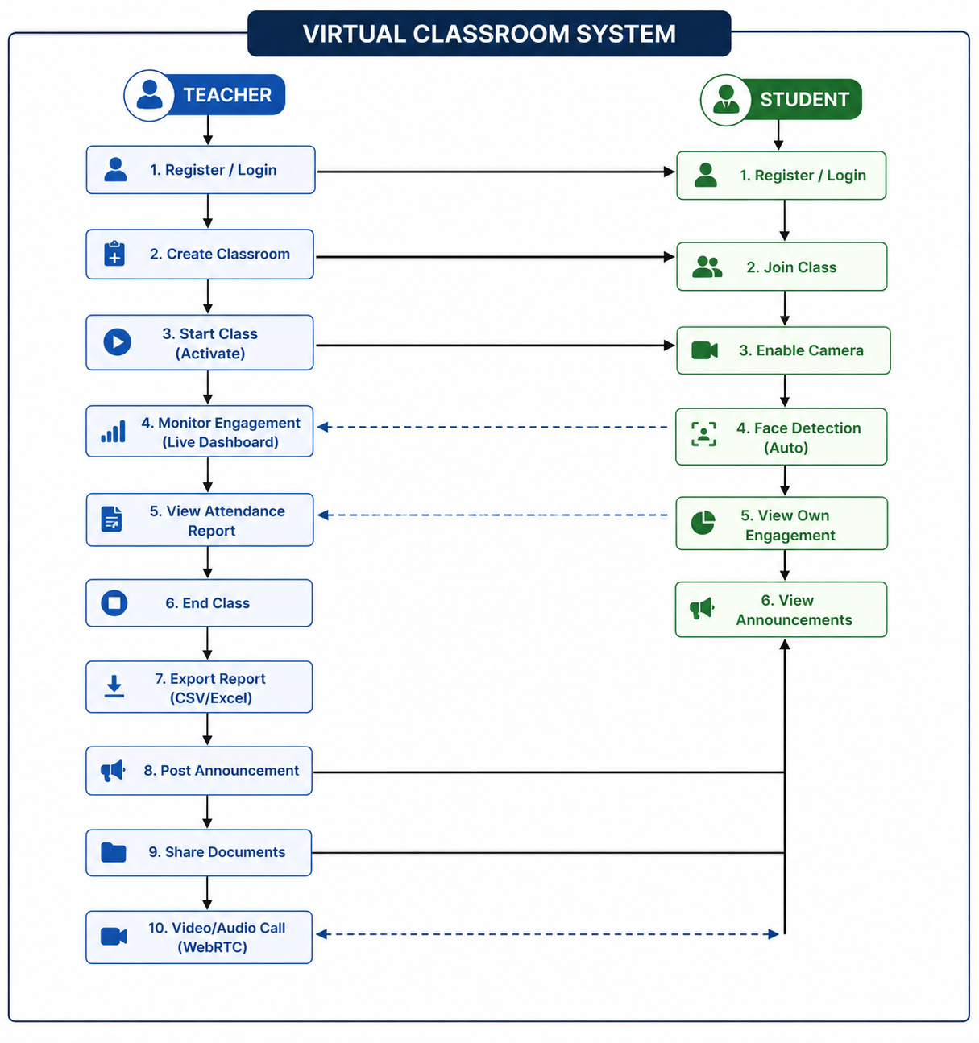

CHAPTER 4

SYSTEM ARCHITECTURE

4.1 Architectural Overview

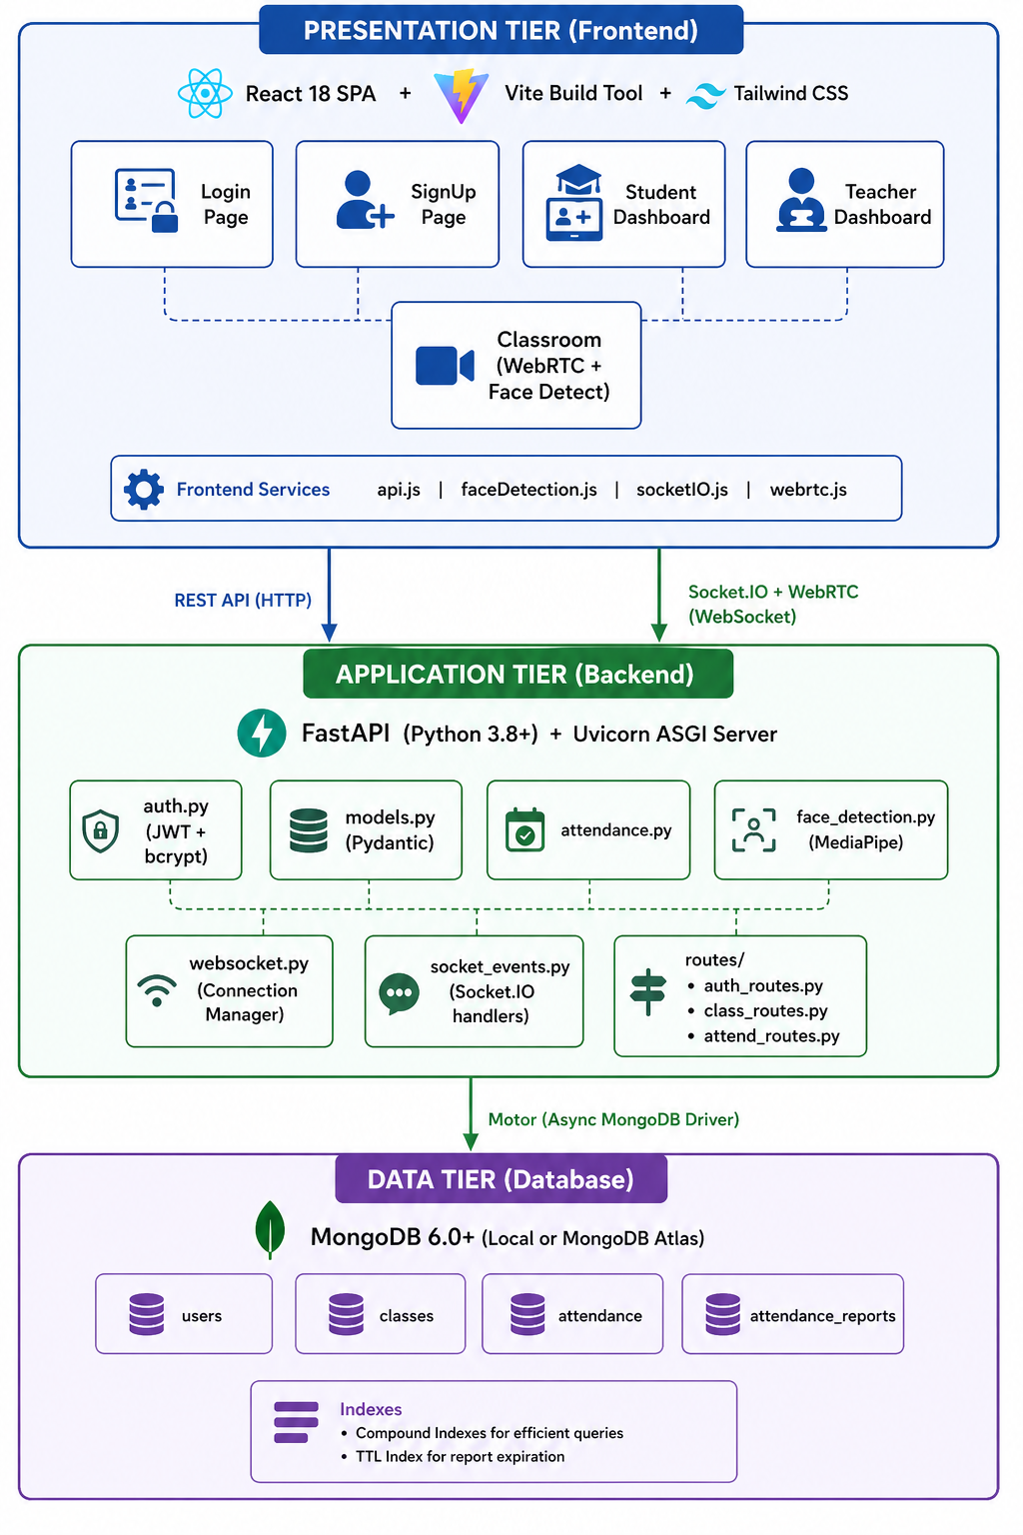

4.2 Frontend Architecture
The frontend is a React 18 Single Page Application (SPA) built with Vite as the build tool and Tailwind CSS for styling. Key architectural decisions:

Component Hierarchy
- App.jsx — Root component with React Router and authentication state management.
- Pages: Login.jsx, SignUp.jsx, StudentDashboard.jsx, TeacherDashboard.jsx, Classroom.jsx, AnnouncementsPage.jsx, DocumentsPage.jsx
- Components: Header.jsx, Sidebar.jsx, TopBar.jsx, ControlBar.jsx, VideoGrid.jsx, VideoTile.jsx, EngagementList.jsx, LiveEngagementPanel.jsx, AttendanceTable.jsx, AttendanceReportModal.jsx, CreateClassModal.jsx, ClassCard.jsx, ChatPanel.jsx, DoubtsPanel.jsx, SettingsPanel.jsx, PWAInstallBanner.jsx
- Services: api.js (REST API client), faceDetection.js (face-api.js wrapper), socketIO.js (Socket.IO client), webrtc.js (WebRTC manager with star topology)
- Hooks: useEngagementDetection.js (face detection interval and engagement status), useActiveSpeaker.js (audio level detection), usePWAInstall.js (Progressive Web App install prompt)
- Context: ThemeContext.jsx (global dark/light theme management)
- Layouts: DashboardLayout.jsx (shared dashboard wrapper)

State Management
The application uses React local state (useState, useEffect) and React Context for theme management. User authentication state is persisted in localStorage and managed by the root App.jsx component.

Routing
React Router v6 handles page navigation with role-based route guards: - /login and /signup — public routes (redirect if authenticated) - /student-dashboard — student-only - /teacher-dashboard — teacher-only - /classroom/:id — authenticated users only - /announcements — teacher-only - /documents — authenticated users

4.3 Backend Architecture
The backend is built with FastAPI, a modern, high-performance asynchronous Python web framework. The ASGI server is Uvicorn wrapped with Socket.IO’s ASGIApp middleware. Key modules:

Core Modules
Module |  |  | File | Responsibility
Configuration |  |  | config.py | Environment variable loading via Pydantic BaseSettings
Database |  |  | database.py | MongoDB connection with Motor async driver, non-blocking startup
Models |  |  | models.py | 20+ Pydantic models for request/response validation
Authentication |  |  | auth.py | JWT creation/validation, bcrypt hashing with SHA-256 pre-hash
Face Detection |  |  | face_detection.py | MediaPipe Face Mesh wrapper with graceful fallback
 | Attendance | attendance.py |  |  | AttendanceManager class for session tracking and report generation
 | WebSocket | websocket.py |  |  | ConnectionManager for WebSocket connections
 | Socket Events | socket_events.py |  |  | Socket.IO event handlers for real-time classroom management

API Routes
Route Module | Prefix | Key Endpoints
auth_routes.py | /auth | POST /register, POST /login, GET /me, PUT /profile, PUT /password
class_routes.py | /class | POST /create, GET /{id}, POST /{id}/join, POST /{id}/activate, POST /{id}/deactivate, GET /teacher/classes, GET /student/classes, DELETE /{id}
attendance_routes.py | /attendance | POST /start, POST /metadata, POST /end, GET /report/{class_id}/{session_id}, GET /reports/{class_id}, GET /live/{class_id}, GET /export/{class_id}/{session_id}, GET /export-excel/{class_id}/{session_id}
join_request_routes.py | /join-requests | POST /request, GET /pending/{class_id}, POST /accept/{id}, POST /reject/{id}
announcement_routes.py | /announcements | POST /, GET /class/{class_id}, DELETE /{id}
document_routes.py | /documents | POST /, GET /class/{class_id}, DELETE /{id}, POST /{id}/view

4.4 Real-Time Communication Layer
The system uses two complementary real-time communication technologies:

Socket.IO (Signaling + Data Channel)
- Connection establishment: Client connects to the backend Socket.IO server with JWT auth token
- Room management: Socket.IO rooms correspond to class IDs; participants join/leave rooms
- Event types: join-classroom, leave-classroom, engagement-update, attendance-update, end-class, student-joined, student-left, class-ended
- Auto-reconnection: Exponential backoff with up to 10 reconnection attempts

WebRTC (Audio/Video)
- Topology: Star — teacher connects bidirectionally with each student; students do not connect to each other
- ICE/STUN servers: Google’s public STUN servers (stun.l.google.com:19302)
- Signaling: WebRTC offer/answer/ICE candidate exchange via Socket.IO
- Camera Management: Students can toggle camera display to peers while keeping the physical camera active for face detection (via replaceTrack with a black canvas track)

CHAPTER 5

IMPLEMENTATION

5.1 Development Environment
Tool | Version | Purpose
Python | 3.11 | Backend runtime
Node.js | 18 LTS | Frontend runtime
MongoDB | 6.0 | Database
VS Code | Latest | IDE
Git | Latest | Version control
Chrome DevTools | Latest | Debugging

5.2 Backend Implementation

5.2.1 Application Entry Point (main.py)
The FastAPI application is initialized with a lifespan context manager that handles database connection on startup and cleanup on shutdown. The app is wrapped with Socket.IO’s ASGI middleware to support both REST API and WebSocket connections on the same port.
# main.py — Key sections
app = FastAPI(
title="Virtual Classroom API",
description="Backend API for Virtual Classroom with AI-powered attendance tracking",
version="1.0.0",
lifespan=lifespan
)
# CORS configuration — allows all origins in development
app.add_middleware(CORSMiddleware, allow_origins=cors_origins, ...)
# Socket.IO server
sio = socketio.AsyncServer(async_mode='asgi', cors_allowed_origins=cors_origins)
setup_socket_events(sio)
socket_app = socketio.ASGIApp(sio, app)
# Route registration
app.include_router(auth_router)
app.include_router(class_router)
app.include_router(attendance_router)

5.2.2 Configuration Management (config.py)
Application settings are managed via Pydantic’s BaseSettings, which automatically loads from environment variables and .env files:
class Settings(BaseSettings):
mongodb_url: str = "mongodb://localhost:27017"
database_name: str = "virtual_classroom"
secret_key: str = "your-secret-key-here-change-in-production"
algorithm: str = "HS256"
access_token_expire_minutes: int = 1440 # 24 hours
attendance_threshold: float = 70.0
frame_interval_seconds: int = 5
attendance_retention_hours: int = 24

5.2.3 Authentication Module (auth.py)
The authentication module implements industry-standard security practices:
- Password Pre-Hashing: Passwords are first hashed with SHA-256 before being passed to bcrypt. This approach (used by Dropbox, Django) guarantees the input to bcrypt is always 64 hex characters (64 bytes), safely under bcrypt’s 72-byte limit regardless of UTF-8 encoding.
def _prehash(password: str) -> str:
return hashlib.sha256(password.encode("utf-8")).hexdigest()
def hash_password(password: str) -> str:
return pwd_context.hash(_prehash(password))
def verify_password(plain_password: str, hashed_password: str) -> bool:
return pwd_context.verify(_prehash(plain_password), hashed_password)
- JWT Token Generation: Tokens are created with python-jose library using HS256 algorithm. The payload includes user ID (sub), role, college name, and department for access control.
- Dependency Injection: get_current_user, get_current_teacher, and get_current_student are FastAPI dependencies that decode the JWT token, fetch the user from MongoDB, and verify the role.

5.2.4 Database Module (database.py)
The database module implements a non-blocking connection strategy:
async def connect_db():
global _client, _db_connected
try:
_client = AsyncIOMotorClient(
mongo_url,
serverSelectionTimeoutMS=10000,
retryWrites=True,
retryReads=True,
)
await _client.admin.command("ping")
_db_connected = True
except ServerSelectionTimeoutError:
_db_connected = False
# Do NOT raise — let the app boot so Render detects the port
A lazy-reconnect helper _ensure_connected() retries the ping on subsequent requests if the initial connection failed.

Table 5.1: Backend Python Dependencies
Package | Version | Purpose
fastapi | 0.109.0 | Web framework
uvicorn | 0.27.0 | ASGI server
python-socketio | 5.11.0 | Socket.IO server
python-jose | 3.3.0 | JWT authentication
passlib | 1.7.4 | Password hashing
bcrypt | 4.0.1 | bcrypt algorithm
motor | 3.3.2 | Async MongoDB driver
pymongo | 4.6.1 | MongoDB driver
opencv-python | 4.9.0.80 | Image processing
mediapipe | 0.10.32 | Face detection (server)
numpy | 1.26.3 | Numerical computing
pydantic | 2.10.6 | Data validation
openpyxl | 3.1.0 | Excel export

Table 5.2: API Endpoints Summary
Method | Endpoint | Description | Auth
POST | /auth/register | User registration | No
POST | /auth/login | User login | No
GET | /auth/me | Get profile | Yes
PUT | /auth/profile | Update profile | Yes
PUT | /auth/password | Change password | Yes
POST | /class/create | Create classroom | Teacher
GET | /class/{id} | Get class details | Yes
POST | /class/{id}/join | Join class | Student
POST | /class/{id}/activate | Start session | Teacher
POST | /class/{id}/deactivate | End session | Teacher
GET | /class/teacher/classes | Teacher’s classes | Teacher
GET | /class/student/classes | Student’s classes | Student
DELETE | /class/{id} | Delete class | Teacher
POST | /attendance/start | Start tracking | Yes
POST | /attendance/metadata | Submit face data | Yes
POST | /attendance/end | End tracking | Yes
GET | /attendance/report/{class}/{session} | Get report | Yes
GET | /attendance/live/{class} | Live report | Teacher
GET | /attendance/export/{class}/{session} | CSV export | Teacher
GET | /attendance/export-excel/{class}/{session} | Excel export | Teacher

5.3 Frontend Implementation

5.3.1 Application Setup (App.jsx)
The root component manages: - User authentication state (persisted in localStorage) - React Router configuration with role-based guards - Theme context provider - PWA (Progressive Web App) components
function App() {
const [user, setUser] = useState(() => {
const savedUser = localStorage.getItem('user')
return savedUser ? JSON.parse(savedUser) : null
})
return (
<ThemeProvider>
<BrowserRouter>
<Routes>
<Route path="/login" element={!user ? <Login /> : <Navigate to="..." />} />
<Route path="/student-dashboard"
element={user?.role === 'student' ? <StudentDashboard /> : <Navigate />} />
<Route path="/teacher-dashboard"
element={user?.role === 'teacher' ? <TeacherDashboard /> : <Navigate />} />
<Route path="/classroom/:id"
element={user ? <Classroom /> : <Navigate to="/login" />} />
</Routes>
</BrowserRouter>
</ThemeProvider>
)
}

5.3.2 API Service Layer (api.js)
The API service layer provides a centralized apiRequest() function with: - Automatic JWT token injection from localStorage - Retry logic with exponential backoff (up to 2 retries on 5xx errors) - Automatic session expiry handling (401 → redirect to login) - Structured error message extraction from FastAPI’s validation error format

5.3.3 Key UI Components
TeacherDashboard: Displays created classes, provides “Create Classroom” modal, “Start Class” and “End Class” actions, live engagement statistics, and attendance history.
StudentDashboard: Shows enrolled classes, join-by-class-ID input, upcoming class schedule, teacher announcements, and notifications.
Classroom: The core component (~92KB, the largest in the codebase). Manages: - WebRTC initialization and peer management - Video grid rendering with speaker detection - Camera/microphone toggling - Face detection integration (via useEngagementDetection hook) - Attendance tracking lifecycle (start → track → end) - Chat and doubts panels - Screen sharing - Control bar with mute/camera/leave/screen-share buttons - Live engagement panel for teachers

Table 5.3: Frontend Node.js Dependencies
Package | Version | Purpose
react | 18.2.0 | UI library
react-dom | 18.2.0 | DOM rendering
react-router-dom | 6.22.0 | Client-side routing
socket.io-client | 4.7.2 | Socket.IO client
lucide-react | 0.344.0 | Icon library
tailwindcss | 3.4.1 | CSS framework
vite | 5.1.4 | Build tool

5.4 Face Detection Implementation

5.4.1 Client-Side Detection (faceDetection.js)
The client-side detection is the primary detection mechanism, designed for privacy:
- Library Loading: face-api.js is loaded dynamically from CDN as a UMD module. Three models are loaded: TinyFaceDetector, FaceLandmark68Net, and FaceRecognitionNet.
- Detection Process:
export async function detectFaces(videoElement) {
const detections = await faceapi
.detectAllFaces(videoElement, new faceapi.TinyFaceDetectorOptions({
inputSize: 320,
scoreThreshold: 0.5
}))
.withFaceLandmarks()
const faceCount = detections.length
const faceDetected = faceCount > 0
const multipleFaces = faceCount > 1
}
- Attention Score Calculation: A composite score (0–100) is computed from:
  - Center Score (30%): How centered the face is relative to the video frame
  - Size Score (30%): Face area as a proportion of total frame area (ideal: 10–30%)
  - Looking Score (40%): Nose-to-eye-center offset as a proxy for head yaw
attentionScore = Math.round((centerScore * 0.3 + sizeScore * 0.3 + lookingScore * 0.4))
- Face Tracker (createFaceTracker): A utility that runs detection at configurable intervals (default: 5 seconds) and invokes a callback with results. Supports start/stop/pause/resume.

5.4.2 Engagement Detection Hook (useEngagementDetection.js)
The React hook bridges face detection results with the WebRTC signaling system:
Engagement Status Logic: - Multiple faces detected → "distracted" - Single face, attention score < 55 → "distracted" - Single face, attention score ≥ 55 → "attentive" - No face detected → "not-detected"
Present/Absent Rule:
const isPresent = cameraOn && status === 'attentive'
A student is only marked “present” when their camera is enabled AND the engagement status is “attentive.” This prevents false-present scenarios.

5.4.3 Server-Side Detection (face_detection.py)
The server-side MediaPipe-based detector serves as a fallback/complementary analysis mechanism:
- Face Mesh Initialization: MediaPipe’s Face Mesh is configured for single-face detection with 0.5 confidence thresholds.
- “Looking at Screen” Algorithm: Uses six landmark positions:
  - Nose tip (#1), Chin (#152)
  - Left eye outer (#33), Right eye outer (#263)
  - Left mouth corner (#61), Right mouth corner (#291)
- Three Conditions for “Looking at Screen”:
  - Centered: Horizontal deviation of face center from image center < 30%
  - Symmetrical: Ratio of min(eye_distance, mouth_distance) to max > 0.7
  - Proper Pose: Nose-to-chin vertical distance > 50 pixels
looking_at_screen = is_centered and is_symmetrical and has_proper_pose
- Graceful Degradation: If MediaPipe/OpenCV are not installed (e.g., on a cloud deployment without native libraries), the detector returns stub values (True, True) to prevent the system from marking all students absent.

5.5 Attendance Algorithm
The attendance tracking follows a lifecycle: Start → Track → End → Finalize.

Phase 1: Start Attendance
When a student joins an active class: 1. An attendance record is created in MongoDB with status = "in_progress" 2. face_detected_at_least_once is initialized to False (strict mode) 3. Timer tracking begins

Phase 2: Real-Time Tracking
Every 5 seconds, the student’s browser: 1. Runs face detection on the webcam feed 2. Computes engagement status (attentive, distracted, not-detected) 3. Emits an engagement-update event via Socket.IO to the teacher 4. The backend may also process submitted metadata to update engagement_duration_seconds

Phase 3: End & Finalize
When the teacher ends the class: 1. Class duration is computed: ended_at - session_started_at 2. For each student, engagement ratio = engagement_seconds / class_duration_seconds

CHAPTER 6

TESTING AND RESULTS

6.1 Testing Methodology
The system was tested using a combination of: - Unit Testing: Individual functions (password hashing, JWT generation, face detection) - Integration Testing: API endpoint testing with Swagger UI and cURL - System Testing: End-to-end testing of the complete user flow - Manual Testing: Real-world testing with multiple users on different devices

6.2 Unit Testing
Key unit tests include: - Password hashing and verification (SHA-256 pre-hash + bcrypt) - JWT token creation and expiration - Face detection with various head poses and lighting conditions - Engagement percentage calculation

6.3 Integration Testing
API endpoints were tested using the auto-generated FastAPI Swagger UI at /docs: - Registration with valid/invalid data - Login with correct/incorrect credentials - Class creation, joining, and activation - Attendance start, metadata submission, and end - Report generation and export

6.4 System Testing Results

Table 6.1: Test Cases and Results
Test ID | Test Case | Expected Result | Actual Result | Status
TC-01 | Register teacher account | Account created, 201 response | Account created successfully | ✅ Pass
TC-02 | Register with existing email | 400 error “Email already registered” | Correct error returned | ✅ Pass
TC-03 | Login with valid credentials | JWT token returned | Token received | ✅ Pass
TC-04 | Login with wrong password | 401 error | Correct error returned | ✅ Pass
TC-05 | Create classroom | Class created with unique ID | Class created | ✅ Pass
TC-06 | Create class with duplicate ID | 400 error | Correct error returned | ✅ Pass
TC-07 | Student joins class | Student added to enrolled list | Student enrolled | ✅ Pass
TC-08 | Start class session | Session activated, session_id generated | Session started | ✅ Pass
TC-09 | Face detected, looking at camera | Engagement updates with “attentive” | Status correctly sent | ✅ Pass
TC-10 | Face not detected | Status “not-detected” emitted | Correct status | ✅ Pass
TC-11 | Looking away from camera | Status “distracted” emitted | Correct status | ✅ Pass
TC-12 | Multiple faces detected | Status “distracted” emitted | Correct status | ✅ Pass
TC-13 | End class, >70% engagement | Student marked “Present” | Correct marking | ✅ Pass
TC-14 | End class, <70% engagement | Student marked “Absent” | Correct marking | ✅ Pass
TC-15 | End class, face never detected | Student marked “Absent” (strict mode) | Correct marking | ✅ Pass
TC-16 | Teacher sees live engagement | Real-time bars update every 5s | Updates received | ✅ Pass
TC-17 | Export CSV report | CSV file downloaded | File downloaded | ✅ Pass
TC-18 | WebRTC audio/video | Bidirectional A/V between teacher-student | A/V working | ✅ Pass
TC-19 | Socket.IO reconnection | Auto-reconnects after network drop | Reconnected | ✅ Pass
TC-20 | Concurrent 5 students | All engagement tracked simultaneously | All tracked | ✅ Pass

6.5 Performance Analysis

Table 6.2: Performance Metrics
Metric | Value
Face detection latency (client-side) | ~120ms per frame (TinyFaceDetector)
Face detection latency (server-side) | ~45ms per frame (MediaPipe)
API response time (auth endpoints) | ~150ms average
API response time (class endpoints) | ~100ms average
Socket.IO message latency | ~30ms (local), ~200ms (cloud)
WebRTC connection establishment | ~2–3 seconds
Memory usage (browser tab, active detection) | ~180 MB
MongoDB query time (indexed lookups) | ~5ms
Concurrent student capacity (tested) | 30 students per class

CHAPTER 7

CONCLUSION AND FUTURE ENHANCEMENTS

7.1 Conclusion
This project successfully designed, implemented, and tested an AI-Powered Student Engagement Monitoring System for online classrooms. The key contributions of this work are:
- Privacy-First Architecture: By performing face detection entirely in the browser using face-api.js and transmitting only boolean metadata to the server, we eliminate privacy concerns associated with video transmission to external servers.
- Dual-Layer Face Detection: The system supports both client-side (face-api.js/TinyFaceDetector) and server-side (MediaPipe Face Mesh) face detection, providing flexibility for different deployment scenarios.
- Strict Attendance Mode: The dual-condition requirement (face detected at least once AND engagement ≥ threshold) prevents false-positive attendance marking, addressing a common weakness in existing systems.
- Real-Time Engagement Dashboard: Teachers receive live, per-student engagement status updates every 5 seconds via Socket.IO, enabling immediate intervention when students become disengaged.
- Integrated Platform: Unlike existing tools that provide only video conferencing or only proctoring, this system combines classroom management, WebRTC video/audio, face detection–based attendance, announcements, documents, and reporting in a single unified web application.
- Production-Ready Deployment: The non-blocking database startup, automatic reconnection strategies, configurable CORS, and TTL-based report expiration make the system suitable for cloud deployment (tested on Render).
The system demonstrates that AI-powered engagement monitoring can be implemented in a web browser with acceptable performance (~120ms detection latency, ~180MB memory usage) while maintaining student privacy through client-side processing.

7.2 Future Enhancements
The following enhancements are planned for future development:
- Emotion Detection: Integrate emotion recognition (happy, confused, bored) using facial expression analysis to provide deeper pedagogical insights.
- Gaze Tracking: Implement eye gaze estimation to distinguish between looking at the screen versus looking at notes or another monitor.
- Analytics Dashboard: Create comprehensive analytics with charts showing engagement trends over multiple sessions, per-student improvement tracking, and class-level comparisons.
- Mobile Application: Develop a React Native mobile app for students to attend classes from smartphones with camera-based face detection.
- Breakout Rooms: Implement small-group breakout rooms within a class session for collaborative activities.
- Live Polls and Quizzes: Add in-class polling and quiz functionality to boost active engagement.
- Recording and Playback: Record class sessions with engagement overlay for post-session review.
- Email Notifications: Automated email alerts to students about upcoming classes and to teachers about low-engagement students.
- Redis Caching: Add Redis for caching frequently accessed data (class lists, user profiles) to reduce MongoDB load.
- Multi-Language Support: Internationalization (i18n) for supporting multiple languages in the UI.
- TURN Server Integration: Add TURN server support for WebRTC in restrictive network environments where STUN alone is insufficient.
- Advanced Cheating Detection: Detect tab switching, screen recording software, or VPN usage to enhance academic integrity.

APPENDIX A: SOURCE CODE

https://github.com/computer897/Aiml.git

APPENDIX B: SCREENSHOTS

B.1 Login Page
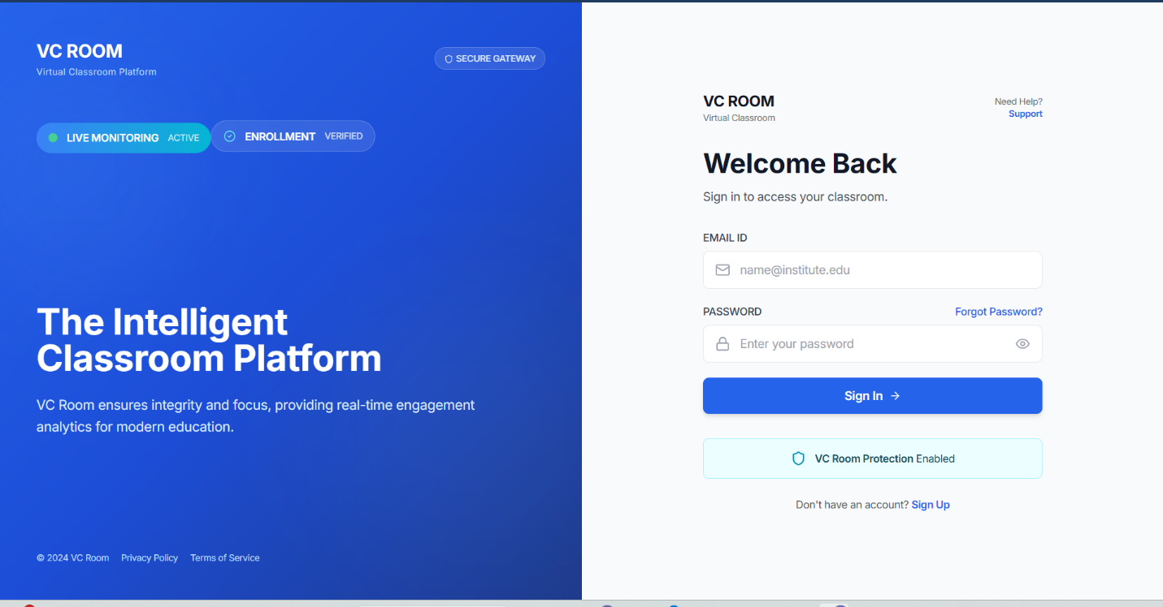

B.2 Registration Page
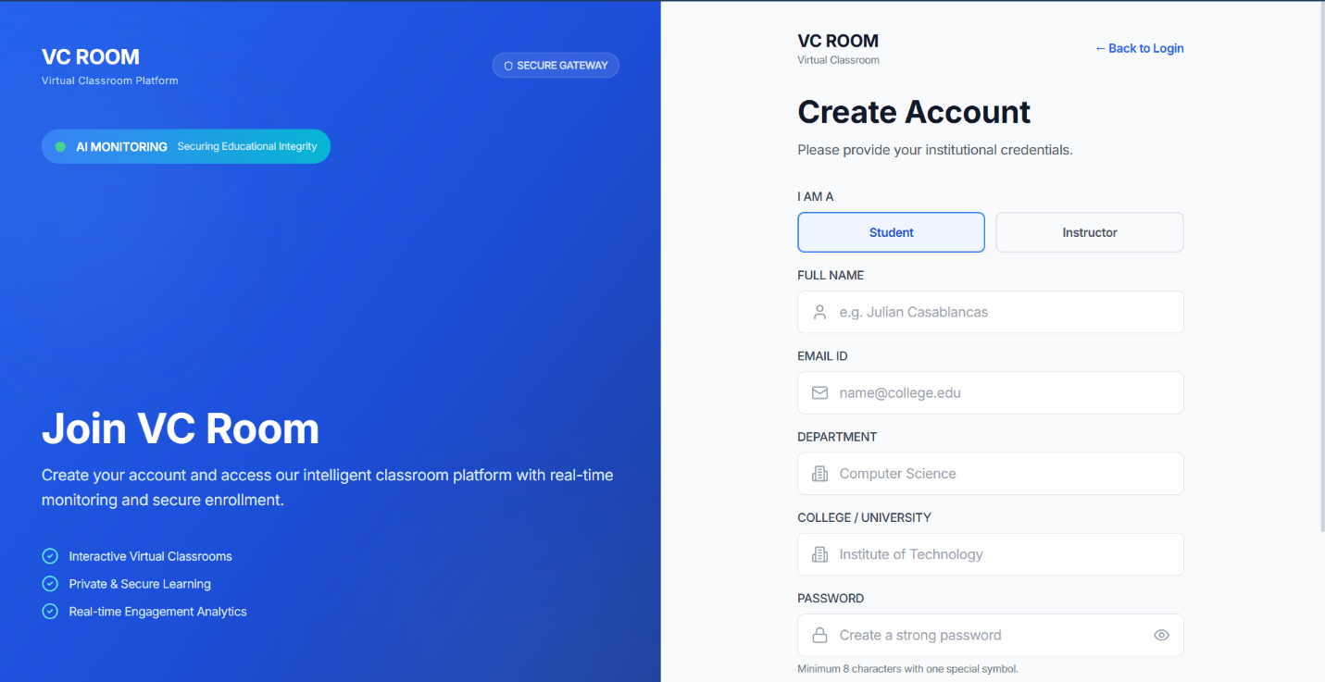

B.3 Teacher Dashboard
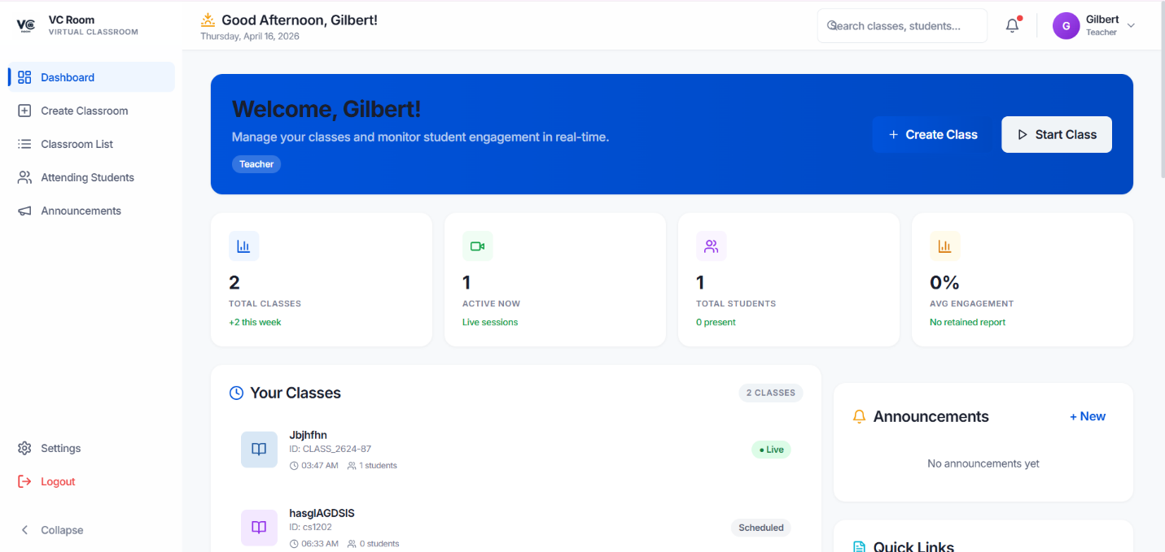

B.4 Student Dashboard
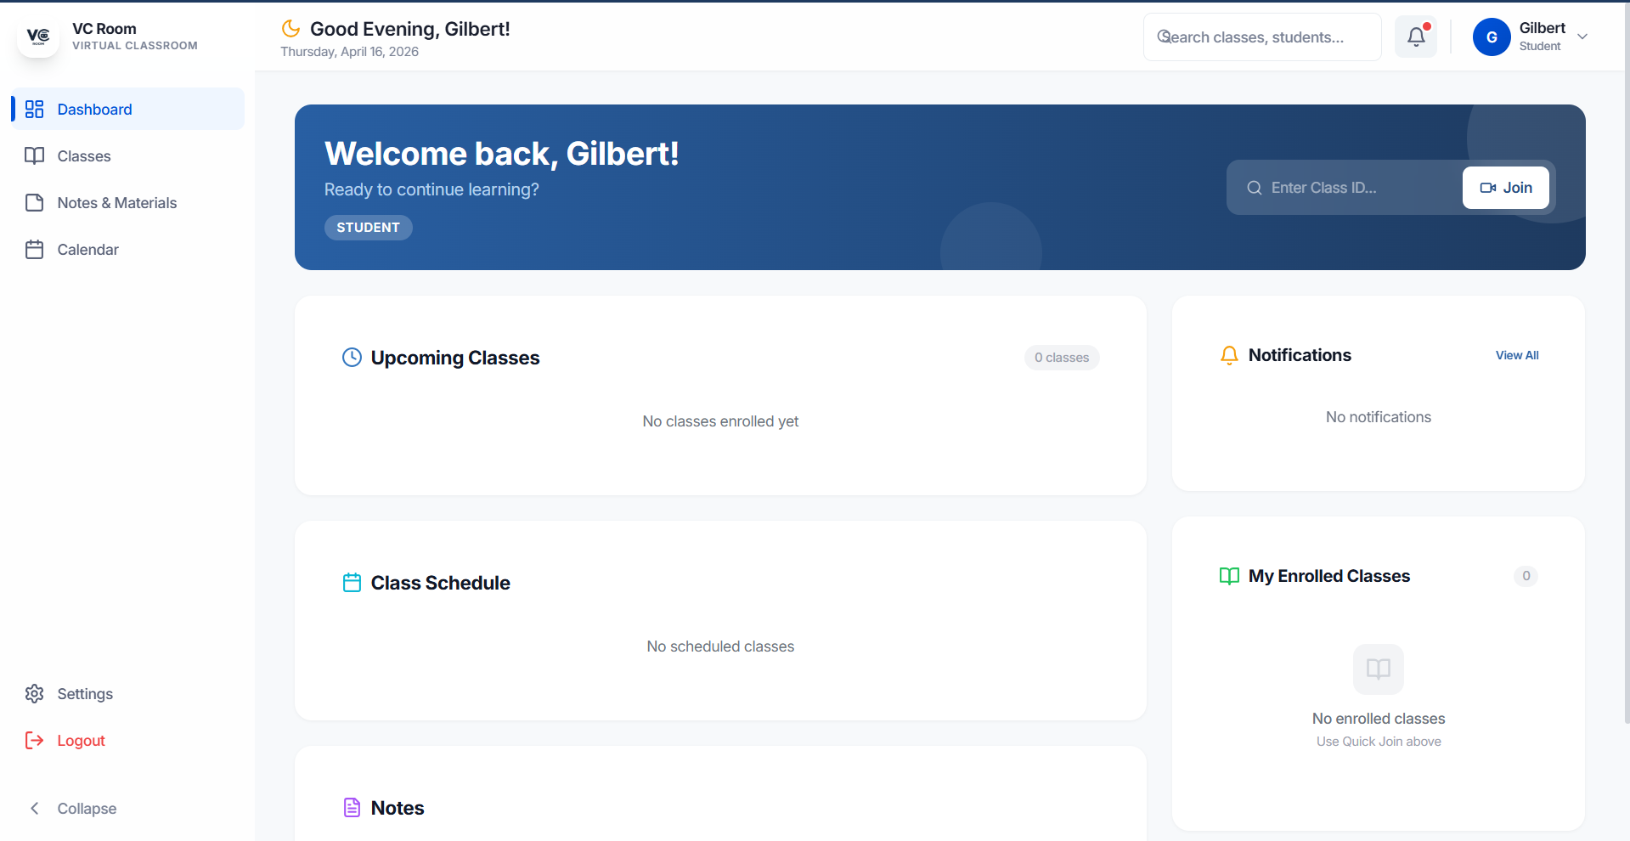

B.5 Create Classroom Modal
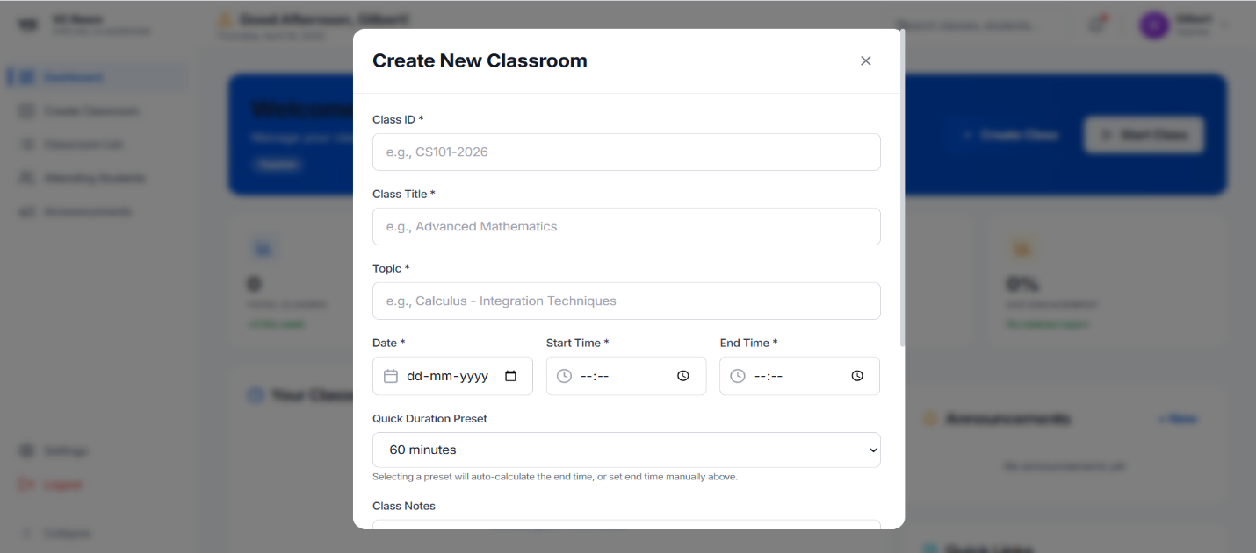

B.6 Virtual Classroom — Teacher View
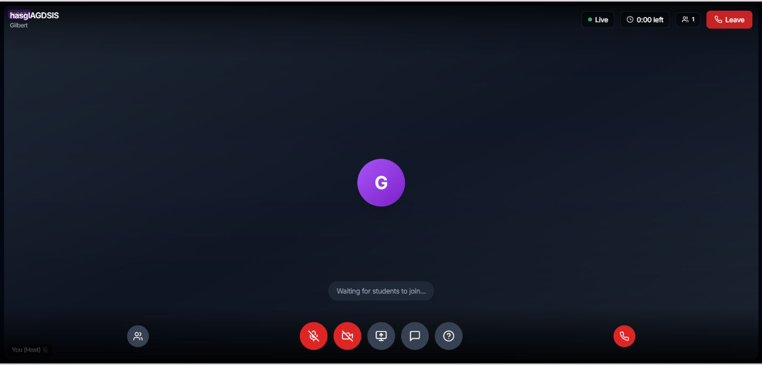

B.7 Virtual Classroom — Student View
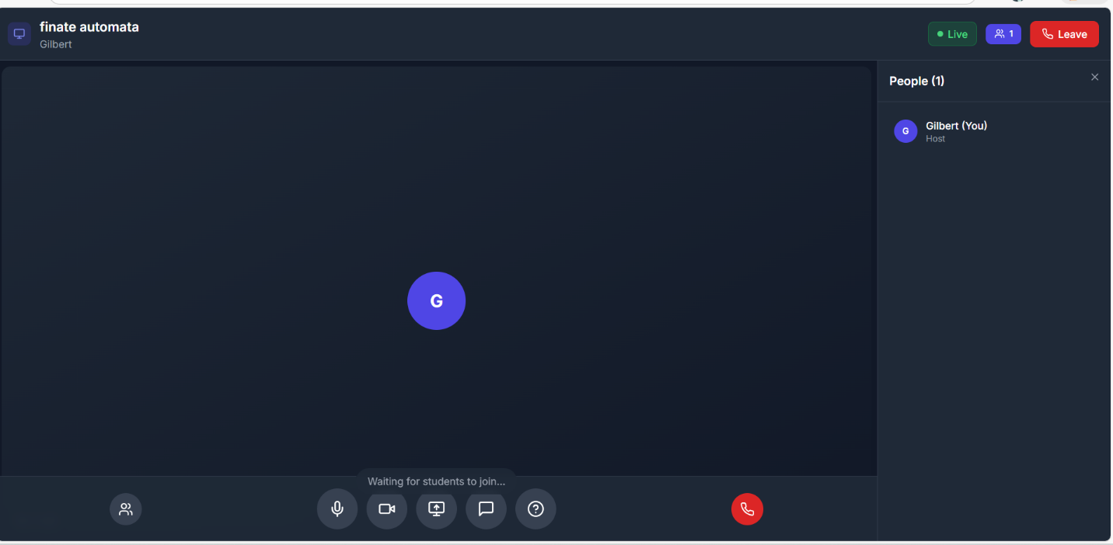

B.8 Live Engagement Panel
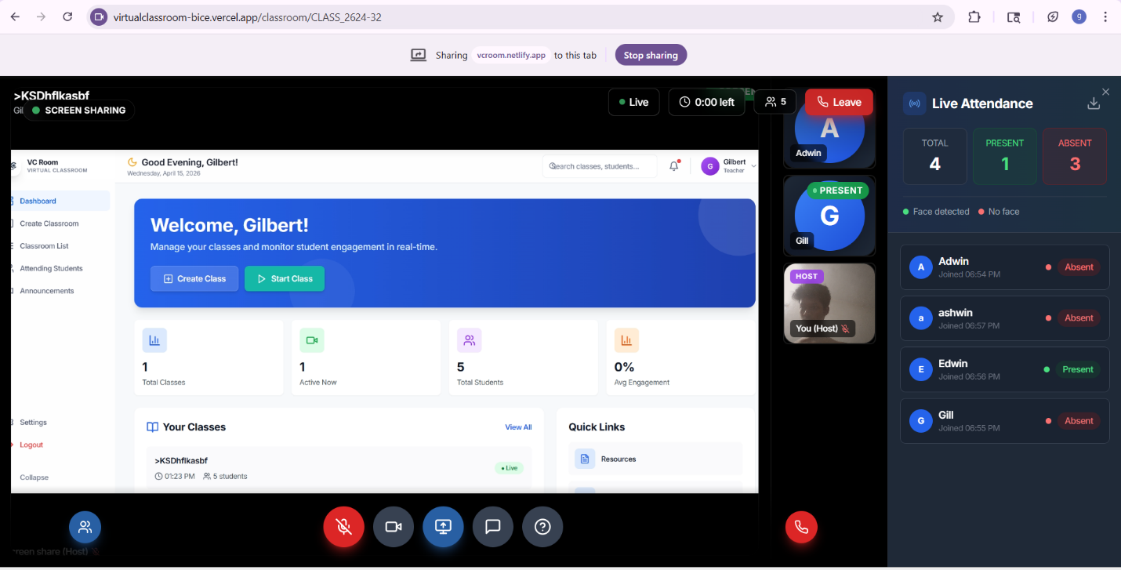

B.10 Settings Panel
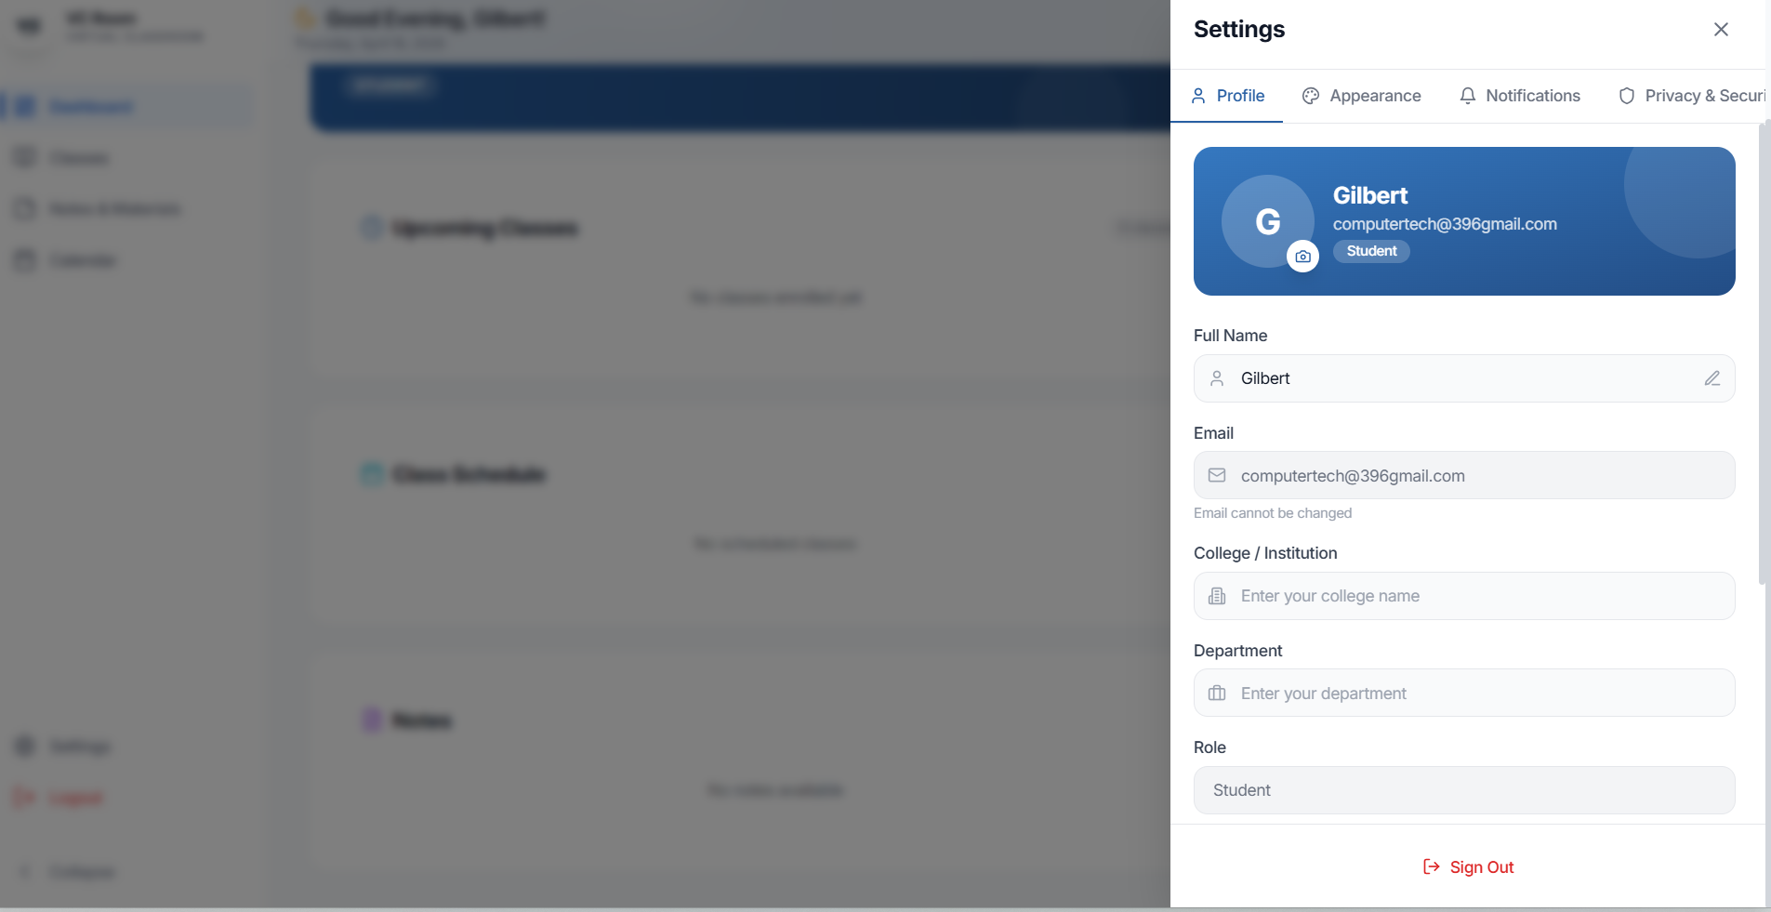

REFERENCES

[1] P. Viola and M. J. Jones, “Robust Real-Time Face Detection,” International Journal of Computer Vision, vol. 57, no. 2, pp. 137–154, 2004.
[2] N. Dalal and B. Triggs, “Histograms of Oriented Gradients for Human Detection,” in Proc. IEEE Conf. Computer Vision and Pattern Recognition (CVPR), 2005, pp. 886–893.
[3] K. Zhang, Z. Zhang, Z. Li, and Y. Qiao, “Joint Face Detection and Alignment Using Multitask Cascaded Convolutional Networks,” IEEE Signal Processing Letters, vol. 23, no. 10, pp. 1499–1503, 2016.
[4] Justadudewhohacks, “face-api.js — JavaScript API for face detection and face recognition in the browser and Node.js with TensorFlow.js,” GitHub Repository, 2018. [Online]. Available: https://github.com/justadudewhohacks/face-api.js
[5] Y. Kartynnik, A. Ablavatski, I. Grishchenko, and M. Grundmann, “Real-time Facial Surface Geometry from Monocular Video on Mobile GPUs,” Google AI Blog, 2019. [Online]. Available: https://ai.googleblog.com/2019/03/real-time-ar-self-expression-with.html
[6] X. Zhu and D. Ramanan, “Face Detection, Pose Estimation, and Landmark Localization in the Wild,” in Proc. IEEE Conf. Computer Vision and Pattern Recognition (CVPR), 2012, pp. 2879–2886.
[7] V. Lepetit, F. Moreno-Noguer, and P. Fua, “EPnP: An Accurate O(n) Solution to the PnP Problem,” International Journal of Computer Vision, vol. 81, no. 2, pp. 155–166, 2009.
[8] I. Fette and A. Melnikov, “The WebSocket Protocol,” RFC 6455, IETF, 2011. [Online]. Available: https://tools.ietf.org/html/rfc6455
[9] Socket.IO, “Socket.IO Documentation,” 2024. [Online]. Available: https://socket.io/docs/v4/
[10] A. Oat and V. Oat, “WebRTC: Real-time Communication for the Open Web Platform,” W3C, 2021. [Online]. Available: https://www.w3.org/TR/webrtc/
[11] FastAPI, “FastAPI Documentation,” 2024. [Online]. Available: https://fastapi.tiangolo.com/
[12] MongoDB, “MongoDB Documentation,” 2024. [Online]. Available: https://www.mongodb.com/docs/
[13] Google, “MediaPipe Solutions Guide,” 2024. [Online]. Available: https://developers.google.com/mediapipe/solutions
[14] React, “React Documentation,” 2024. [Online]. Available: https://react.dev/
[15] Tailwind CSS, “Tailwind CSS Documentation,” 2024. [Online]. Available: https://tailwindcss.com/docs

